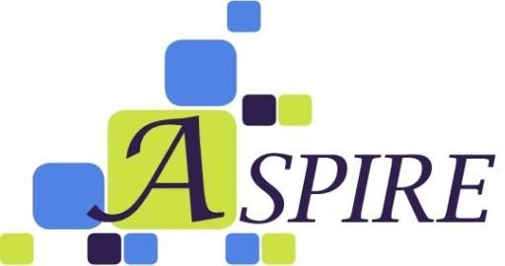

ASPIRE Promotes Self-Sufficiency!
www.actionpathways.ngo/aspire
Cumberland County Office (910-223-0116)
4525 Campground Rd Fayetteville, NC 28314

Sampson County Office (910-249-4805)
360 County Complex Road, #117 Clinton, N.C. 28328

What Is ASPIRE?
ASPIRE is an acronym for Achievement, Success, Progress, Independence, Readiness and Evolve, words that exemplify ASPIRE’s core principles.
ASPIRE is a comprehensive, family-centered and holistic program that assists low- wealth individuals and families in obtaining skills, knowledge, and resources needed in order to become self-sufficient.
ASPIRE’s mission is to promote high-quality work ethics, economic literacy, and positive family values throughout Cumberland and Sampson counties.
Program goals and services will provide services with assisting participants in obtaining employment. Services include:
- Employment readiness training/workshops
- Educational assistance (GED & Continuing Education courses)
- Financial management/budgeting
- Nutrition/Health assistance
- Maintaining affordable/safe housing
- Community involvement- (Leadership Program)

Program Requirements:

- Must be Cumberland/Sampson County resident
- Must provide proof of identification of ALL household members over the age of 18
- Income must be at or below Federal Poverty Guidelines for household size

Action Pathways, Inc. is a non-profit community organization.

- Income includes Wages, Federal subsidies (TANF, SNAP, Housing supplement, Section- 8 Vouchers), Unemployment Benefits, Supplemental & Social Security, Child Support, Alimony, Monetary Contributions, etc…
- Income must be provided for all household members related by birth, marriage, and/or adoption within a (single dwelling) household
- Must be willing to comply with ALL program guidelines (employment search, workshop attendance, must demonstrate gradual progression toward action plan goals, and must maintain bi-weekly contact with case manager)
- Must be willing to seek and obtain employment

How Do I Enroll?

All interested applicants must complete an application and meet with a Case Manager in order to have an Intake Assessment to be considered for the ASPIRE Program.

2023 INCOME POVERTY GUIDELINES at 125%
Persons in family/household | Poverty Guidelines
1 | $18,225
2 | $24,650
3 | $31,075
4 | $37,500
5 | $43,925
6 | $50,350
7 | $56,775
8 | $63,200
For families/households with more than 8 persons, add $9,080 for each additional
Person.

(Detach application)
Self Sufficiency Program Application
Legal Name:
Address: Apt./Unit #:
City |  |  |  | State: NC Zip Code:
Mailing Address: (If different)
Home Phone Number: ( ) |  |  |  | Cell Phone: ( )
Birth Date : / / Age: |  |  |  | Gender: Male Female
Ethnicity: Hispanic Non-Hispanic
Race: Black/African American White Native American Other: ____________________
Marital Status: Single Married Divorced Separated Widow/er
Education Level: 0-8 9-12 HS Diploma GED Some College College/Tech Degree
Email Address:
Current Needs: __________________________________________________________________________

Who referred you to us?___________________________________________________________________
FAMILY INFORMATION
Family Member Name | Relationship to applicant | Date of Birth | Age |  | Race | Gender | Ethnicity | Education
Total Number in Family (include applicant, infants, children and adults): ______
Income Source (check all applicable)
Employment Pension/Retirement Union Benefits
Unemployment Work Study General Assistance (Monetary Contributions)
Alimony/Child support Work First Benefits/TANF Rental Income
Social Security /SSI Worker’s Compensation Other ______________________________________________
Have you previously received assistance from us or participated in any other Action Pathways
Programs? Yes No If yes, please list the programs, include dates _________________
I certify that all information provided herein is true to the best of my knowledge. I am aware that this information is subject to review and verification as well as the documentation to support it. I am aware that if I have knowingly given false information in order to receive assistance prosecution can take place.

I am aware that I may be denied assistance if I am found ineligible. I understand that I have the right to appeal any denial of service or assistance for which I may be eligible.

I allow release of information contained herein for the purpose of verification of my situation.

________________________________________ _______________________
Applicant’s Signature Date

